

**HES MOCK MARKING GUIDE 2022**

**UGANDA CERTIFICATE OF EDUCATION**

**GOEGRAPHY**

**PAPER 2**

1. (a) **A SKETCH MAP OF GEZIRA IRRIGATION SCHEME SHOWING**

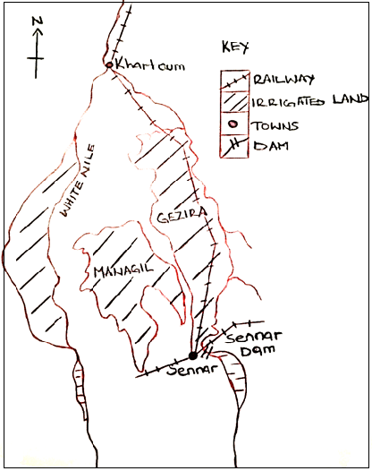 **IRRIGATIONS AREAS, TOWNS, DAMS AND WHITE NILE**

**N:B** Marginal information 6 marks

General drawing 1 mark

Total 7 marks

(b) Describe the factors that have favored the establishment of Gezira irrigation scheme in Sudan.

**Physical Factors**

* Presence of a relatively gentle landscape thus allowing both irrigation and drainage to be done easily and cheaply.
* Presence of a permanently reliable supply of water for irrigation from the Blue Nile and White Nile Rivers.
* Presence of fertile soils for crop growth. The Blue Nile and White Nile seasonally flooding bringing fertile alluvial soils in the area.
* Presence of a large land area for cultivation due to sparse population.
* The existence of low incidence of pests and diseases due to the arid climate favored crop yields.

**Human Factors**

* Availability of adequate capital to purchase farm inputs like fertilizers, ginning factories and others.
* Availability of a large market for the crops grown both at home and abroad
* Presence of high levels of technology used involves adequate skill to harvest flood waters and distributing devices.
* Availability of an abundant and cheap labor supply provided by the nationals.
* Favorable government policies of setting up the scheme, allowing people to settle and produce food and cash crops.

**Any 8 x 1 = 8 marks**

(c) Explain the contributions of the scheme to the people of Sudan.

* It has led to diversification of the agricultural products eg from growing crops only to rearing of livestock.
* It has provided employment opportunities to the people of Sudan like machine operators, farmers and drivers which improve on their standard of living.
* It has also provided raw materials for agro-based industries thus promoting industrialization eg cotton ginneries allocated at Maringan and Hassa Hissa.
* It earns revenue for the government of Sudan through taxation of agro processing industries thus development of roads and railways.
* It also earns the country foreign exchange through the export of crops especially cotton which is used in the development of infrastructure like roads, dams and others.
* Urban centers have been developed infrastructure like roads eg sennar and Khartoum towns.
* farmers have learnt modern farming methods eg irrigation and use of fertilizers which has contributed to increased crop yields.
* The scheme has promoted corporation among the tenants as well as bilateral relationship with countries importing commodities like USA.

**Any 6 X 1 = 6 Marks**

(d) Outline the problems facing Gezira irrigation scheme in Sudan.

* Price fluctuations of the crops grown.
* Presence of pests and diseases which attack and affect quality of crops.
* Urbanization with related problems like high crime rates
* Salination due to high rates evaporation.
* Silting that results in the blocking of irrigation canals
* Large quantities of water are lost htrough evaporation.

**Any 4 x 1 = 4 marks**

**25 marks**

1. (a) name the;
2. A Mozambique Current
3. B Lake St. Lucia
4. 1 Durban , 2 Port Shestone
5. C Umfolosi D Tugela
6. E Indian Ocean

**7 x 1 = 7 marks**

(b) Describe the conditions favoring sugar cane growing in Natal province in South Africa.

**Physical factors**

* Presence of the low altitude in the coastal areas results in hot temperatures of 210C for quick growth and ripening of the crop
* The sunny conditions in the region increase the sugar content in the canes
* Occurance of heavy rainfall of 1500mm and above brought by the warm Mozambique current permits the growing of perennial crops like sugar canes.
* Presence of fertile alluvial well- drained soils which favour sugar cane growth.
* Presence of the generally gentle landscape which has enabled extensive mechanization and irrigation to occur.

**Human factors**

* Availability of large sums of capital by large companies to invest in sugar cane production
* Availability of a large market for the sugar produced both at home and in the neighboring countires like Lesotho.
* Availability of high levels of technology which has enabled the construction of sugar mills.
* Accessibility of well-developed infrastructure like roads and railways from farms to industries and later markets. Availability of abundant supply of cheap labour to work on the farms from South African and Swaziland.

**Any 8 x 1 = 8 marks**

(c) Explain the benefits of sugar cane growing in Natal province to the development of South Africa

* Generation of employment opportunities to marry south Africans on the plantations and sugar processing industries
* The plantations provide raw materials to industries eg for sugar processing industries in towns like Durban.
* It is a source of revenue to the government through taxing sugar processing industries thus development of roads
* Farmers have acquired skills in scientific methods of crop cultivation which the y apply in their individual farms
* Promotion of international relationship through expectation and trade with other countries
* Source of foreign exchange through exportation of the sugar cane and its products to the neighboring states like Lesotho.
* Promoted industrial infrastructural development like roads and railways to ease trade and movement.
* It has led to urbanization of towns like Durban and port Shepstone with developed roads and railways.

**Any 6 x 1 = 6 marks**

(d) Outline the problems still facing the sugar cane growers in Natal Province South Africa.

* Over production resulting in limited market
* Soil erosion leading to loss of soil fertility
* High costs of productions
* Presence of existence weeds which compete with soil nutrients.
* Pests and diseases like caterpillars
* Soil exhaustion due to monoculture
* Drought, results in crop failures.

**Any 4 x 1 = 4 marks**

**25 marks**

1. (a) A line and bar graph showing the temperature and rainfall in station Y.

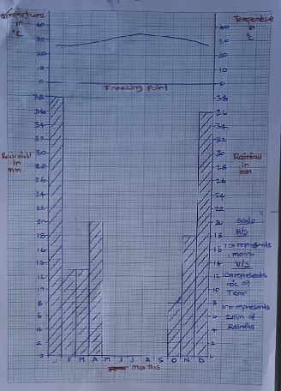

(b) (i) mean annual rainfall of station Y

=

=

=

= **150 mm per year** 1 mark

(ii) Annual temperature range of station Y

= highest mean monthly temperature – lowest mean monthly temperature

= 350C – 260C

= **90C**  1 mark

**N:B** marks are only awarded for calculations (answers) with units.

(c) Describe the characteristics of the climate of the area where station Y is found.

* Rainfall is very low and unreliable usually less than 280mm per annum.
* Rare torrential down pour occur which lead to temporary flooding.
* There is a very high evaporation rate.
* Temperatures are very hot usually above 300C
* There is high daily temperature range
* Station Y experiences very hot days and very cold nights
* There is absence of cloud cover
* The area also experiences severe and strong windstorms
* There is low atmospheric pressure most of the year round.

**Any 7 x 1 = 7 marks**

(d) (i) Describe any four economic activities that take place in the area where station Y is found.

* The area is used for nomadic pastoralism (herds) i.e. grazing of livestock like cattle and goats on the scanty pastures.
* Agriculture interns of crop cultivation is also carried out especially heat resistant and fast maturing plants eg the date palm.
* The landscape and desert features are important tourist attractions giving rise to tourism.
* Acqua – culture ie the farming of bee for honey and other products is also carried out in the area.
* There is also settlement it he area though the population is sparse due to low rainfall received in the area.

**Any 4 x 1 = 4 marks**

(ii) Giving reasons for your answer, state the climatic region where station Y is found.

* Station Y is found in the desert climatic region
* Reason: because the area experiences very low and unreliable rainfall usually less than 250mm per annum and the mean annual rainfall of station Y is 150mm which is less and true of the desert climate region.

**N.B:** any reason(s) provided it is derived from the characteristics of the desert climate is correct.

**Any 1 x 1 = 1 mark**

**25 marks**

1. (a) name the
2. A River Nile

B River Congo

C River Orange

1. Latitude marked 1 the equator
2. Lake marked 2 lake chad
3. Delta marked D the Nile delta
4. Water body marked 3 Atlantic ocean

**7 marks**

(b) With the aid of illustration, describe the process for the formation of the delta marked D.

* A delta is a large, flat low lying plain of river deposits built by a river mainly in the old stage where it flows into the sea or lake. Most deltas have a triangular shape.
* A river in its old stage has its speed reduced due to the low gentile gradients of the land and heavy loads of sediments carried.
* As a river enters the failing calm waters of the sea/ lake, it deposits its load of the sediments at the river mouth,. This is usually in times of floods when the river over floods in its banks.
* The deposition blocks, the river mouth and leads to the river dividing and subsidizing into several minor interconnecting channels called distributaries.
* The sediments deposited accumulate over time as there are no strong ocean currents to erode them. This later builds a delta.
* Patches of water are enclosed with the sediments deposited to form lakes known as lagoons as well as swamps.
* The delta is later colonized by plants making its level to rise.

**ILLUSTRATION OF A DELTA**

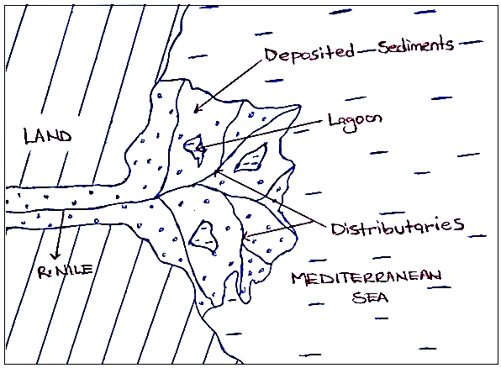

***Description 4 marks***

***Illustration 2 marks***

**N.B:** candidates should explain the formation of the delta in detail.

Key words in the process of formation should be emphasized.

(c) Describe the importance of the delta marked D to the people of Egypt.

* Cultivation of crops takes place due to the presence of fertile alluvial soils, thus providing food for the population.
* The delta act as a tourist attraction hence earning Egypt foreign exchange for development of infrastructure like roads.
* The delta contains petroleum deposits used as a source of energy for domestic and industrial purposes.
* The swampy vegetation covering the delta is used as raw materials in the craft industry thus providing income to the people.
* The relatively flat landscape of the delta is ideal for locating settlements, industries and transport routes thus promoting urbanization eg Alexandria and port said.
* The delta lagoons contain silt goods for fish food hence attracts fish giving rise to fishing activities.
* The delta is used for study or research purposes such as field work in geography.

**Any 5 x 1 = 5 marks**

(d) (i) Explain the problems associated with the delta marked

* The delta tends to harbor disease carrying vectors like mosquitoes causing malaria and sometimes death of the people.
* The delta is flat, low-lying plain that is subjected to flooding causing damage of croplands, settlements and property.
* Deposition of sediments at the river mouth of the delta creates shallow waters which hinders navigation.
* The saline water from the Mediterranean sea reduces the productivity of the delta for agricultural purposes.
* Being fertile, the delta attracts dense settlements leading to overcrowding and ;and shortage.
* There is hot temperatures in the delta area which is unsuitable for settlements due to low attitude.

**Any 4 x 1 = 4 marks**

(ii) Outline the steps being taken to solve the problems in D (i) above.

* Regular degrading to reduce silting at the river mouth.
* Enacting of lanes against settlement in river valleys in deltas
* Evacuation of people during flood times.
* Control of diseases by spraying with chemicals and treatment of people infected.
* Establishment of industries outside the river valley or mouth and on the delta.

**Any 3 x 1 = 3 marks**

**25 marks**

**PART II: STUDIES IN DEVELOPMENT**

**REGION I : NORTH AMERICA**

1. (a) A pie chart showing the relative importance of the different employment sectors in British

Columbia.

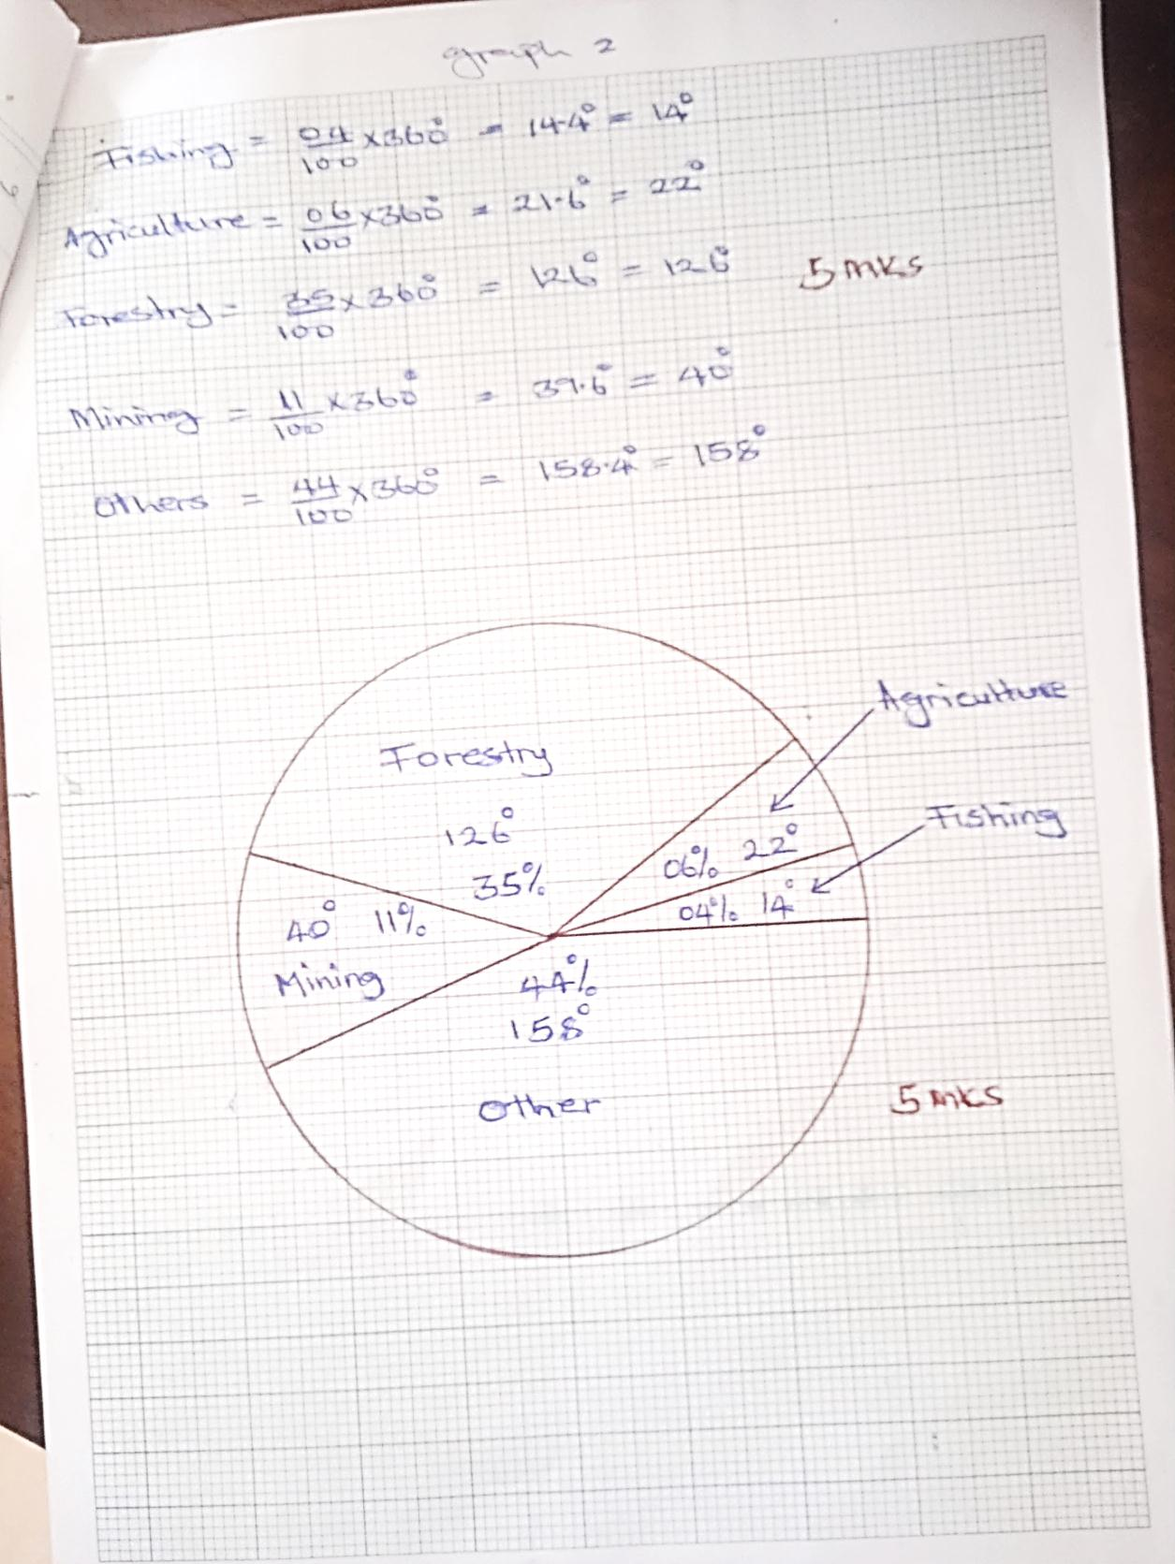

(b) (i) Identify the relative importance of the mining sector in British Columbia.

* Mining is the second largest employing sector in British Columbia next to forestry.
* It employs 11% of the population.

**2 marks**

(ii) Describe the factors which have favored the development of the mining industry in British

Columbia.

**Physical factors**

* Presence of a wide range of minerals in sufficient quantities for commercial exploits eg copper, zinc, lead and gold.
* Presence of minerals of high value such as petroleum, neutral gases and gold that fetch high income on international markets.
* Presence of some minerals near the surface making their exploitation easy and cheap.
* Presence of a reliable supply of fresh water for processing the minerals from rivers like Fraser, Columbia and Skeena.

**Human factors**

* Availability of advanced technology in exploitation and mining eg use of satellites off .shore mining and adit mining.
* Availability of skilled labour like geologists, geophysicist and others to work in the mining industry.
* Availability of large sums of capital to inject in the mining operations.
* Presence of well-developed and transport routes linking many mining areas for transportation of the minerals to the processing centres.

**Any 6 x 1 = 6 marks**

(c) Explain the contributions of the mining sector to the development of British Columbia.

* Provision of foreign exchange to the provider of British Columbia for the development of roads and railways.
* Generation of employment opportunities to many people thus improving their standard of living.
* Mining has stimulated industrial development by provision of raw materials for mineral based industries.
* There is also production of petroleum and natural gas used for fuel for domestic and industrial purposes.
* Promotion of international relationships with countries that import the minerals eg USA.
* Urban centres have been developed in the mining areas with related advantages like developed roads eg Prince George.

**Any 4 x 1 = 4 marks**

(d) Outline the problems faced by the mining sector in British Columbia.

* Some minerals occur in areas of rugged terrain.
* High rates of exploitation thus exhaustion of some minerals.
* Fluctuation of prices on minerals in the world market.
* Existence of severe winter season that interferes with mining activities.
* High transport costs
* Accidents occur during mining operations.

**Any 3 x 1 = 3 marks**

1. (a) **A sketch map of New York City showing Rivers, Islands, Airports and States.**

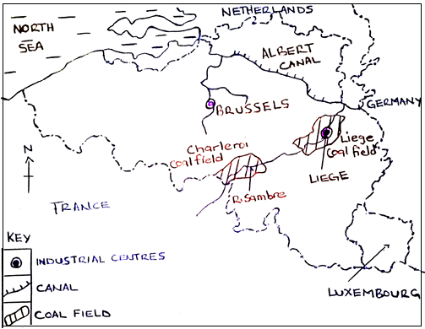

***Marginal information =7 marks***

***General drawings = 1 marks***

(b) Describe the conditions that led to the growth of New York as a city / port.

**Physical Factors (Conditions)**

* Presence of deep water, that allows large ocean going vessels to anchor near the shores.
* Presence of a natural well sheltered harbor protected from strong winds allowing anchorage of marine vessels.
* The ice free conditions allow the port facilities to be used all year round.
* The eastern sea board, which makes it accessibility to major markets easy.
* The topography of new york is relatively flat which made the construction of various transport systems, buildings easy.

**Human factors (conditions)**

* The place was historically settled by the early European settlers especially the Dutch and later the British who largely developed it.
* Establishment of a well-developed and efficient transport routes by road side.
* Availability of sufficient capital to develop the port facilities and huge sky crappers.
* Availability of skilled man power which enabled the construction and maintenance of the city and port facilities.
* The establishment of many manufacturing and service industries attracts many people for employment opportunities.

**8 x 1 = 8 marks**

(c) Explain the problems facing New York as a city / port.

* Congestion of ships at the port resulting in delays in loading and out loading of goods.
* Pollution of air, water and bad through oil spills, emission of carbon monoxide fumes from industries leading to diseases like asthma.
* Pollution by industries leads to formation of smoke resulting in poor visibility and accidents.
* High population results in shortage of land for expansion of the city and port facilities.
* Unemployment due to improved technology such as containerization which lead to loss of jobs.
* Shortage of capital for the construction and maintenance of modern city and port facilities.
* Congestion and overcrowding results in poor sanitation and easy spread of diseases.
* Shortage of housing which has resulted into development of slums with poor sanitation.

**Any 6 x 1 = 6 marks**

(d) Outline the functions of New York City.

* It is an administrative center
* It is an industrial center with more the n 40,000 industries
* It is a commercial center and the leading wholesale and retail trade in USA.
* It is a transport center with developed transport routes like roads.
* It is a tourist center with both museum’s art collection and the unique architecture of the building itself.

**Any 3 x 1 = 3 marks**

1. (a) Name the
2. States marked

1 Alaska

2 United States Of America (USA)

1. island marked

3 Green Land

1. provinces marked

A British Columbia

B Saskatchewan

1. Urban centers marked

C Edmonton

D Winnipeg

**7 marks**

(b) Identify any four characteristics of wheat growing in Canada.

* Monoculture is practiced ie large land area is devoted to the growing of a single crop which wheat.
* The farms are highly mechanized.
* Extensive farming is practiced ie wheat growing covers a large area.
* Farms are scientifically managed involving the use of improved seed varieties and fertilizers.
* There is a change of wheat farms to mixed farming due to increasing surplus of wheat.
* The farms are very large covering thousands of hectares of over 200 hectares.

**Any 4 x 1 = 4 marks**

(c) Describe the factors which favored wheat farming in Canada.

**Physical Factors**

* Presence of extensive cheap land, which enabled the salting up of large farm sizes covering thousands of hectares.
* Presence of a relatively flat landscape that favors extensive mechanization to occur.
* Existence of fertile black chernozem soils for continued crop growth.
* The warm summer temperatures favor rapid growing and ripening of the grains.
* The original vegetation was grassland, which was easy to clear and suitable for wheat growing.

**Human factors**

* Availability of a large market of wheat grown in USA, Europe and Africa.
* Availability of a large sum of capital, which enable extensive cultivation and mechanization of the farms.
* Availability of skilled labour experienced in wheat growing and processing.
* The continuous scientific research is carried out which has led to the development of quick maturing and cold resistant wheat varieties
* Availability of a stable political atmosphere that attract agricultural investors to Canada.

**Any 8 x 1 = 8marks**

(d) Explain the steps being taken to solve the problems facing wheat in Canada.

* Mechanizing of farms to solve the problem of shortage of labour is being taken.
* Carrying out for market research to the market for wheat grown in Canada.
* Blowing of warm air is on the farms to raise the air temperatures so as to reduce the effect of frost.
* Constructing of more port facilities at the existing ports to reduce congestion and delays.
* Carrying out continuous research leading to the development of better and high yielding seeds.
* Diversification crop production to reduce over dependency on crop. This reduces the effects of price fluctuations.
* Applying of fertilizers and manure to restore soil fertility and structure.
* Spraying with chemicals to eradicate pests and diseases in the farms.

**6 x 1 = 6marks**

***25 marks***

**REGION II: RHINELANDS**

1. (a) **A Sketch Map of Switzerland Showing River, Country, Urban Centers and Railway Lines**.

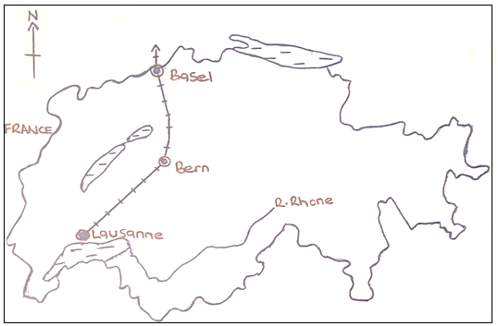

**Physical factors**

* Presence of the Swiss plateau which is relatively flat making the construction of railway line easy.
* Presence of many passes in the Alps which other low lying areas for easy crossings in the mountains for the development of railway transport.
* The strategic location of Switzerland like heart of Europe makes her a natural route way of international rail links from north to south end east to west.
* The Rhine river is navigable from its links from north to south and east to west.
* The Rhine river is navigable from its mouth up to Basel. In order to convey large quantities of goods imported to the other parts of Switzerland, a dense railway network was developed.

**Human factors**

* Availability of abundant and reliable hydroelectricity power supply which has enabled her to electrify 99% of her railway system.
* Availability of skilled labour used in the construction of electrified railway systems.
* Supportive government policy of investing in the developing of railway transport by building electrified railway lines.
* The use of advanced technology which enabled the electrification of the railway system as well as construction of tunnels to avoid steep gradients.
* The need to transport thousands of workers who commute to their work places each day from far distances also led to the development of railway systems.

**8 x 1 = 8 marks**

(c) Describe the problems facing the Swiss transport system.

* Switzerland possesses no coal and oil and therefore depends on imported ones whose costs are ever increasing..
* Switzerland is a land locked with no easy and direct access to the sea.
* Flooding of rivers in spring due to melt waters from the glaciers in the Alps limits their use for transport.
* High costs, of constructing roads and railways especially in the mountainous religions of Alps.
* Congestion on the transport routes especially on roads during winter causing delays.
* Many rivers are not navigable due to waterfalls and rapid eg upper section of the Rhine River.
* The mountainous terrain in the Alps and the jura creates problems and high costs in the construction of roads and railway lines.

**6 x 1 = 6 marks**

(d) Outline any three other transport system that exist in Switzerland.

* Road transport
* Water transport (navigation)
* Air transport
* Use of cable cars

**Any 3 x 1 = 3 marks**

**25 marks**

1. (a) Name the;
2. River marked

1 Rhine river

1. Lake marked

2 Lake Ussell (Ysell)

1. Agricultural activity carried out in the region marked

A cattle (diary) farming

1. Towns marked

B Amsterdam

C Breda

1. Countries marked

D Belgium

E Germany

**7 marks**

(b) Describe the factors favoring dairy farming in the Netherlands.

**Physical factors**

* Presence of a reliable supply of fresh water from lakes and rivers for the livestock to drink and yield much milk eg Lake Yssel.
* Presence of the temperate climate with cool to warm summer’s ideal for outdoor cattle rearing.
* Presence of fertile pearl and clay soils which favor the growth of pasture and folder crops used as livestock feeds.
* Occurance of low altitude which promotes cool conditions suitable for dairy farming.
* Presence of extensive land for salting up large farms in the province of Freeland north Holland. South Holland and drenthe.

**Human factors**

* Availability of an abundant supplementary fodder crops such as corn, hay and alfalfa to feed the livestock.
* Availability of a ready market for the dairy products not only in Netherlands but also in the surrounding European rich nations and Asia.
* Research is continuously carried out which had to the production of improved dairy cattle breeds ad discovery of new industrial use of milk and its byproducts.
* The formation of cooperative associations has promoted standardization and grading of dairy products, marketing as well as providing protection for the industries.
* Availability of sufficient capital for investment in dairy farming eg purchases of high quality diary breeds, feed conveyors and electric milking machines as well as paying the workers.

**Any 8 x 1 = 8 marks**

(c) Explain the challenges facing dairy farming in the Netherlands.

* Limited home or domestic market for the products has lowered the production of livestock products.
* Exhaustion of soils for growing pastures resulting in poor quality pastures which lead to low milk yields.
* Shortage of pasture especially during winter when the grazing lands are covered by snow leads to reduced milk production.
* High costs of production due to use of intensive methods of production which reduces the competitiveness of Dutch products on the world market.
* Over production of the cattle products resulting in a fall in market prices and low income received.
* Still completion with other livestock producers like Switzerland, Germany and Belgium which reduces the market for the livestock products of the Netherlands.
* Shortage of land for expensive of livestock farming.
* Occurrence of pests such as moths and caterpillars that destroy pastures for the livestock resulting in low milk yields.

1. **A Sketch Map Of Belgium Showing Sea, Coalfield Region, Canal, Industrial Centers And**

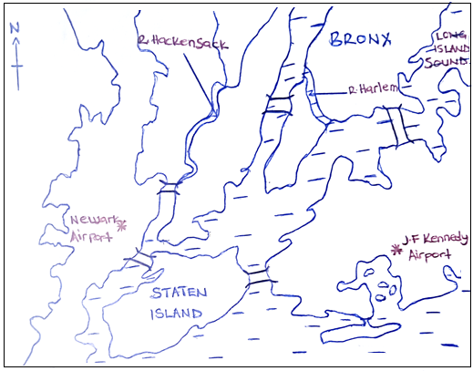 **River**

(b) Describe the factors which have favored industrial development in Belgium.

* Presence of abundant mineral raw materials such as coal in the sambre Meuse region for the iron and steel industry.
* Availability of large quantities of raw materials from the agricultural from the agricultural sector such as tobacco, hops and sugar beef which act as inputs in agro based industries.
* Presence of reliable energy supply inform of large coal reserves which provided initial energy for powering industries.
* High level of technology used which has led to automation of industries and production of high quality goods.
* Establishment of well-developed transport routes by water canals and railways for easy transportation of products to the markets.
* Availability of sufficient capital from both local and foreign investors to set industries e.g. ford and Volvo in the motor industry.
* Belgium has been politically stable for years enabling industrial development to take place steadily over the years.
* Availability to adequate water supply for industrial use from rivers schelt and Meuse for coiling machines, mixing dyes and in cleaning processes.
* Historical factors like Belgium, being the first country in Europe to industrialize following the head of Britain in the industrial revolution.

**Any 8 x 1 = 8 marks**

(c) Explain the benefits of industrialization to the development of Belgium.

* It has led to the growth of urban centres eg Brussels, Antwerp and hiege with developed roads.
* Generations of foreign exchange for development of infrastructures through the exports of industrial goods.
* Provision of employment opportunities in the establishment to many people thus improving on their standards of living.
* Sources of government revenue through taxation of the established industries for the development of infrastructure in the country.
* They contribute to the diversification of the economy reducing over reliance on sectors like mining, tourism and fishing industries.
* Promotion of international relationships with countries like Netherlands, Luxembourg and Germany due to regional trade.
* Provision of large market and agricultural sector like iron and dairy products.

**Any 6 x 1 = 6 marks**

(d) Outline the problems facing industrial development in Belgium.

* Limited capital
* limited skilled labour forces
* Limited domestic market
* Price fluctuation of industrial products
* Congestion on roads that cause delays.
* Pollution caused by the industrial fumes.

**Any 4 x 1 = 4 marks**

**REGION III: CHINA**

1. (a) **A Line Graph Showing Annual Production Of Copper In China (1975 – 1995) In Metric Tons**

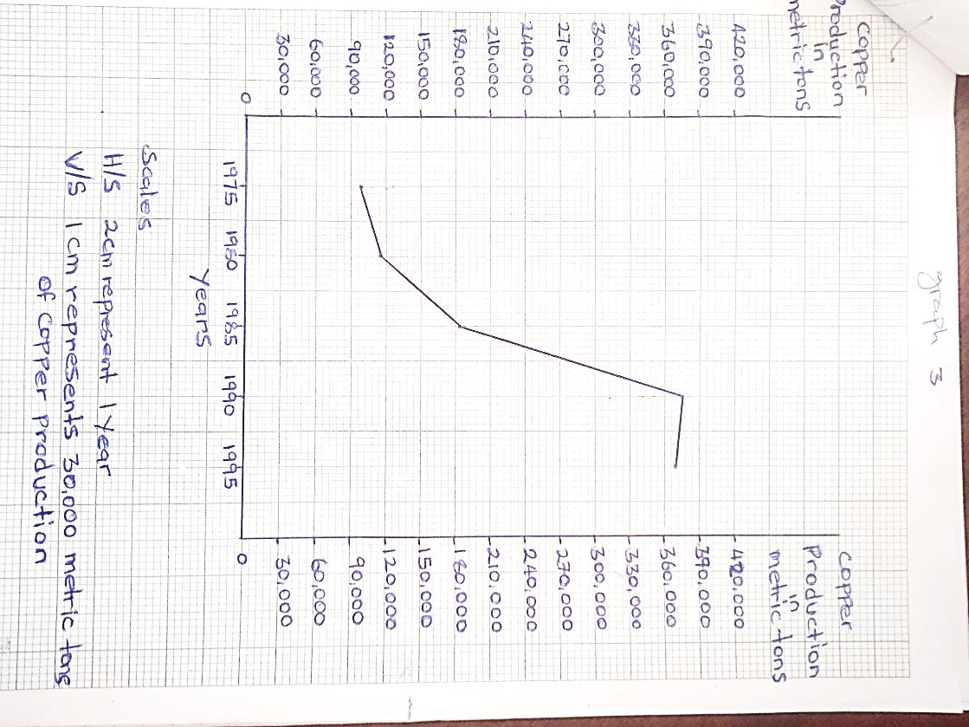

(b) Describe the trend of copper production in china between 1975 and 1995

* There was a slight increase of copper production from the initial production of 100,00 in 1975 to 115,000 metric tons in 1980.
* There was a moderate increase of copper production from 11,500 metric tons in 19500 to 185,000 metric tons in 1985.
* There was a sharp increase of copper production from 185,000 metric tons in 1985 to 375,000 metric tons in 1990.
* There was a slight decrease of copper production from 375,000 metric tons in 1990 to 370,000 metric tons in 1995.

(c) (i) name any two copper mining areas in china.

* Lanzhou
* Chengdu
* Manchuria

(ii) Explain the conditions that have favored copper mining in china.

**Physical Features**.

* The presence of large deposits of copper in the areas of Chengdu, Hangzhou and Manchuria has enabled continuous mining activities for years and years.
* The presence of rivers like the yellow river that provides water for softening the rocks and soil cover in the extraction process and other purposes in the areas of Manchuria.
* The presence of rugged relief in the Lanzhou and Chengdu that discourage other activities like agriculture thus making mining as the best alternative to sue the land available.
* Existence of large land for the establishment of mining sites and industries thus development of mining in China.
* The presence of grass vegetation that is easy to clear for carrying out of copper mining has favoured its development.

**Human Factors**

* China has a developed transport network inform of railways and airways all over the major industrial regions like Manchuria and Tianjin – Beijing and others.
* Availability of adequate capital to invest in the mining of copper by both the lead and foreign investors.
* Availability of a large and ready market due to tis high population which has favored mining of copper in China.
* Political stability ensured by the communist government ensured security required for mining of copper in China.

**Any 6 x 1 = 6 marks**

(d) (i) Outline the problems faced by the copper mining industry in china.

* Existence of a hard basement rocks
* Limited skilled labour
* Mineral exhaustion
* Rugged nature of relief
* Limited market
* Inadequate capital
* Competition with other copper mining countries
* Limited transport network

**Any 5 x 1 = 3 marks**

(ii) Mention any two other minerals mined in China.

* Lead
* Iron ore
* Oil
* Aluminum
* Coal

**Any 2 x 1 = 2 marks**

1. (a) Name the;
2. latitude marked A tropic of cancer
3. rivers marked B River Youjang, C River Dong Jiang
4. water body marked D East China Sea
5. urban centres marked 1 canton (Guangzhou) 2 Nanning 3 Kweiyang

**7 marks**

(b) Describe the conditions that favored agricultural activities in the skiing river basin.

* Presence of fertile alluvial soils that support growth of crops like rice and potatoes.
* Presence of adequate fresh water for irrigation farming eg from skiing river.
* A suitable hot summer temperature leads to quick ripening growth of crops.
* Presence of a large population provides ready market for the crops produced.
* The generally low land flat relief favours rice cultivation in the river basin.
* The large Chinese population in the river basin provided labour to grow and harvest crops.
* Development of the agricultural green revolution that emphasized growing rice and wheat in the region.
* Supportive government policy which encouraged farming through formation of communes
* The Sikiang river basin is linked to efficient transport routes which facilitate marketing agricultural commodities.

**Any 8 X 1 = 8 Marks**

(c) Explain the contribution of the Sikiang river basin to the development of China.

* It leads to provision of food stuffs like rice, wheat, potatoes to improve people’s diet.
* It provides employment to farmers; produce transporters and marketing agents thus improved standards of living.
* It has stimulated growth of agro based industries which pay taxes necessary to development of the country.
* It has strengthened national unity amongst the people through communal farming.
* It has boosted the generation of revenue to the government through taxing farmers and agro based industries.
* It has spear headed the development of water transport on the skiing river thus development of trade.

**Any 6 x 1 = 6 marks**

(d) Outline the problems facing people living along the Sikiang river basin.

* Flooding of river sikiang during June - July.
* Pests and diseases destroy crops.
* Declining soil fertility due to over use of land has led to reduced yields.
* Limited land for extensive farming due to land fragmentation and population pressure leads to low crop yields.
* Use of elementary farming equipment lead to low crop yield.
* Limited cooperation between members in the farming communities lead to low crop yields.

**Any 3 x 1 = 3 marks**

1. (a) **A Sketch Map of China Showing Location of Beijing with Towns, Canal, Great China Wall,**

**Water Body and Rivers.**

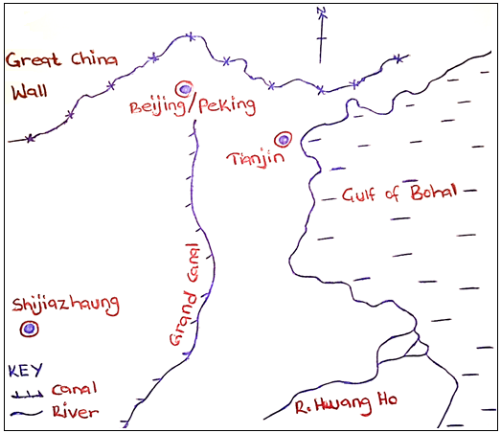

**7 marks for labeling features**

**1 mark for drawing**

(b) Describe factors that led to the development of Beijing as an urban centre.

* The gentle relief makes it easy to construct sky scrapers and transport routes like roads and railways.
* The supportive government policy of developing Beijing, inviting investors thus making it develop into a city.
* The presence of fresh water from rivers like sikianga for domestic and industrial use.
* The availability of well-developed transport and communication system like railways roads, air and water.
* Presence of extensive land for the development of urban center in terms of roads, settlements and industries.
* Beijing’s nearness to the East Coast of China for easy access to the international routes to facilitate trade.
* The availability of stable supply of power for domestic and industrial use thus its development into an urban center.
* Presence of highly skilled labour to construct urban infrastructure like roads and railways.

**Any 8 x 1 = 8 marks**

(c) Explain the problems facing Beijing as an urban center.

* Overcrowding due to a large urban population slowing down movements.
* High crime rates due to unemployment leading to poor standard of living.
* Unemployment of sections of the population leading to poverty and thus determining development.
* Traffic congestion leading to delays and accidents hindering development.
* Over strained social services due to high demand affecting people’s standard of living.
* Pollution of land, water and air due to industrial gasses leading to health problems.

(d) Outline the functions of Beijing as an urban center.

* It is the capital city of china with administrative functions.
* It is an industrial center with facilities for textile manufacturer.
* It is an educational centre with many schools, colleges, universities providing education to people.
* Commercial center with the trading centers hence promoting trade ad commence.
* Recreation functions with stadiums, theatres, sports facilities.
* Cultural centres eg museums, art galleries promoting the conservation of cultures, research and study purposes.
* Tourism center eg the Great Wall of China bringing in foreign exchange used for development.

**Any 3 x 1 = 3 marks**

**END**